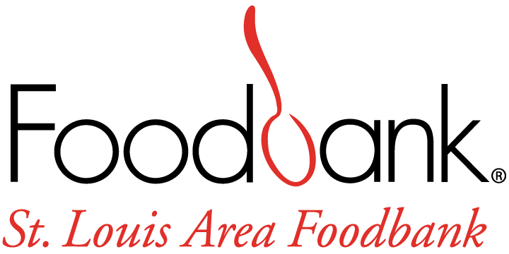

Youth and Family Programs Intern Job Description

GENERAL DESCRIPTION:
The Youth and Family Programs Intern is a volunteer leader who supports St. Louis Area Foodbank’s Programs Department. The Youth and Family Programs Intern will develop skills in nonprofit program and project management and will enhance our ability to provide quality support to all of our Youth and Family Programs (i.e. School Markets and the Summer Family Food Program). The intern will also have the opportunity to attend Food Fairs and Mobile Markets and provide support to the Food Bank’s outreach efforts by supporting Health Education, Advocacy, and SNAP Outreach. The Youth and Family Programs Intern will interface with program partners, residents of the 26 counties the SLAFB serves, and Food Bank staff. The intern may also work with other strategic direction initiatives that the SLAFB is spearheading for growth and success.
WORK LOCATION:
St. Louis Area Foodbank
70 Corporate Woods Drive
Bridgeton, MO 63044

RESPONSIBILITIES:
- Help set up and distribute food to families during open hours at School Markets.
- Work with Youth and Family Programs Coordinator to plan the Summer Food Program.
- Assist in reaching out to additional higher education partners.
- Attend site visits for youth partners as the intern’s schedule allows.
- Go to sites in the community and conduct client surveying of Youth and Family Programs to collect necessary data for our continuous quality improvement process.
- Data entry into databases and Microsoft applications.
- In addition to helping with Youth and Family Programs, the Youth and Family Programs Intern will have the opportunity to help at mobile distributions, help with education or nutrition programming, and attend SNAP Outreach events in the community.
- Support and facilitate photo documentation and storytelling of the clients and the communities we serve during youth events in the community.
In Order to gain a full understanding of the Food Bank and our scope of work, Youth and Family Programs Intern may participate in a variety of program areas including, but not limited to:

- School Markets
- Summer Family Food Program
- Higher Education Partnerships
- Food Fairs and Mobile Food Pantry
- Volunteer Center
- SNAP Outreach team as they work in the community
- Ride with a driver for a food distribution
- Read or participate and reflect on selected articles or webinars related to hunger and food security issues, food bank programs, and advocacy

QUALIFICATIONS:
- Currently enrolled or recently graduated from an accredited college or university
- Non-profit experience preferred
- Strong written, verbal communication and interpersonal skills
- Ability to work cooperatively with different types of personalities
- Proficient with Outlook, Word, Excel, PowerPoint and other web-based applications
- Broad understanding of evaluation of programs
- Ability to work independently and as part of a team
- Reliable transportation and a valid driver’s license
- Passion for the Foodbank mission and the ability to demonstrate SLAFB’s Core Values: Stewardship, Teamwork, Agility, and Respect
The physical demands and work environment characteristics described here are representative of those that must be met by an employee to successfully perform the essential functions of this job. Reasonable accommodations may be made to enable individuals with disabilities to perform the essential functions.
- Employee is routinely required to lift 25 lbs.

TIME REQUIREMENTS
There is flexibility with this internship, but the Youth and Family Programs Intern is expected to work with their supervisor to determine a schedule and hours to fulfill academic requirements or personal experience. This is subject to change if an individual needs to increase or decrease their total number of internship hours. As schedules are made and set, community events for the intern to attend will be scheduled.

YOUTH AND FAMILY PROGRAMS INTERN OBJECTIVES
- In depth understanding of local and national hunger and poverty issues.
- Involvement in the process of planning, implementing, monitoring, and evaluating several programs.
- Learning to manage program resources efficiently.
- Skills and knowledge in data collection and evaluation in communities with limited access to food.
- Opportunity to connect with community members to provide support, compassion, and be able to identify which program best fits their needs.

TO APPLY: Go to https://stlfoodbank.aaimtrack.com/jobs/ or contact Emma Patterson at EPatterson@stlfoodbank.org.

