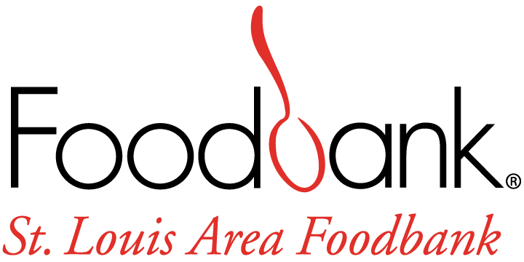

Mobile Programs Intern Job Description

GENERAL DESCRIPTION:
The Mobile Programs Intern is a volunteer leader who supports St. Louis Area Foodbank’s Programs Department. The Mobile Programs Intern will enhance our ability to provide quality support and organization of Food Fairs and Mobile Markets programming and provide support to the Food Bank’s outreach efforts by supporting Health Education, Advocacy, and SNAP (Supplemental Nutrition Assistance Program) Outreach. The Mobile Programs Intern will interface with partnering agency, residents of the 26 counties the SLAFB Serves, and Food Bank staff. The intern may also work with other strategic direction initiatives that the SLAFB is spearheading for growth and success.
WORK LOCATION:
St. Louis Area Foodbank
70 Corporate Woods Drive
Bridgeton, MO 63044

RESPONSIBILITIES:
- Work with Program staff members to create and/or update logic models, program and project plans and other foundational materials.
- Conduct client surveying of the mobile markets and food fairs to collect necessary data and to develop thoughtful analytics to the communities that we serve.
- Data entry into databases and Microsoft applications.
- Work directly with program staff to serve clients. This includes, but is not limited to mobile distributions, education or nutrition programming, and SNAP outreach both in person and over the phone.
- Research best practices and theories for Mobile Market outreach in urban and rural communities.
- Support and facilitate photo documentation and storytelling of the clients and the communities we serve during outreach programs and education facilitation.
- Research and schedule additional resources for clients to have available at mobile distributions.

In Order to gain a full understanding of the Food Bank and our scope of work, Mobile Programs Intern may participate in a variety of program areas including, but not limited to:
- Food On The Move, Food Fairs and Mobile Food Pantry.
- Volunteer Center
- SNAP Outreach team as they work in the community.
- Participate in various capacities
- Ride with a driver for food distribution.
- Read or participate and reflect on selected articles or webinars related to hunger and food security issues, food bank programs, and advocacy.

QUALIFICATIONS:
- Currently enrolled or recently graduated from an accredited college or university.
- Non-profit experience preferred
- Strong written, verbal communication and interpersonal skills.
- Ability to work cooperatively with different types of personalities
- Proficient with Outlook, Word, Excel, PowerPoint and other web-based applications
- Broad understanding of evaluation, programs and logic models
- Ability to work independently and as part of a team.
- Reliable transportation.
- Passion for the Foodbank mission and the ability to demonstrate SLAFB’s Core Values: Stewardship, Teamwork, Agility and Respect

The physical demands and work environment characteristics described here are representative of those that must be met by an employee to successfully perform the essential functions of this job. Reasonable accommodations may be made to enable individuals with disabilities to perform the essential functions.
- Employee is routinely required to lift 25 lbs.

TIME REQUIREMENTS
There is flexibility with this internship, and as an expectation, the Mobile Programs Intern will work with his/her supervisor to determine a schedule and hours to fulfill academic requirements or personal experience. This is subject to change if an individual need to increase or decrease total hours of internship. As schedules are made and set, community events for the intern to attend will be scheduled.

MOBILE PROGRAMS INTERN OBJECTIVES
- In depth understanding of local and national hunger and poverty issues.
- Strong grasp of community and government responses to hunger and poverty.
- Opportunity to build or strengthen groups facilitation and leadership skills.
- Skills and knowledge in data collection and development for communities with limited access to food.
- Opportunity to connect with community members to provide support, compassion, and be able to identify their needs with nutrition education.

TO APPLY: Go to https://stlfoodbank.aaimtrack.com/jobs/ or contact Jessica Murphy at jmurphy@stlfoodbank.org.

